Creating a service deployed by OpenShift Pipeline

Procedure:

In the OpenShift Container Platform web console **Developer** perspective, navigate to **+Add** and select the **Import from Git** option

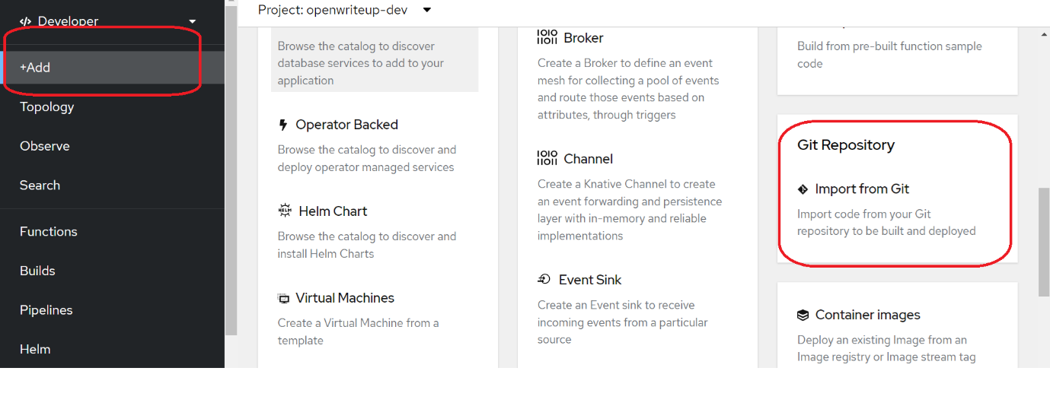

<https://github.com/amitopenwriteup/kqr-pay.git>

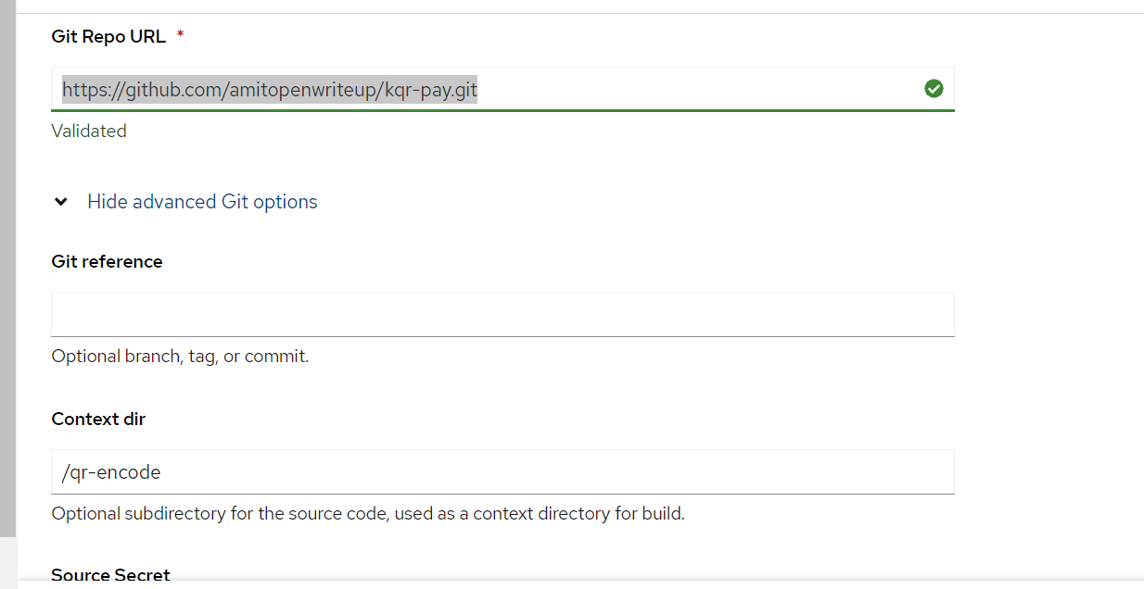

Application name

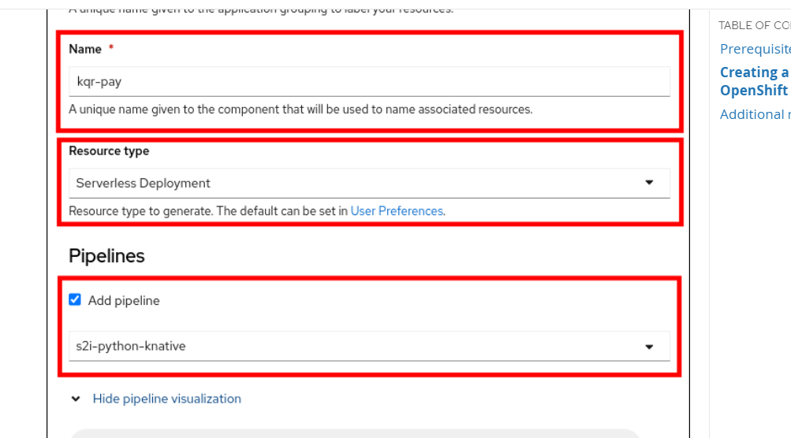

Go to pipeline and check

